**DIGITAL NURTURE 4.0 DEEP SKILLING JAVA FSE-WEEK1**

**NAME: SIVITHA GUNASEKARAN**

**SUPERSET ID: 6413354**

**WEEK 1: ALGORITHMS DATA STRUCTURES**

**Exercise 4: Employee Management System**

**Scenario:**

You are developing an employee management system for a company. Efficiently managing employee records is crucial.

**Steps:**

1. **Understand Array Representation:**
   * Explain how arrays are represented in memory and their advantages.
2. **Setup:**
   * Create a class Employee with attributes like **employeeId**, **name**, **position**, and **salary**.
3. **Implementation:**
   * Use an array to store employee records.
   * Implement methods to **add**, **search**, **traverse**, and **delete** employees in the array.
4. **Analysis:**
   * Analyze the time complexity of each operation (add, search, traverse, delete).
   * Discuss the limitations of arrays and when to use them.

**CODE SAMPLES:**

class Employee {

int employeeId;

String name;

String position;

double salary;

public Employee(int id, String name, String position, double salary) {

this.employeeId = id;

this.name = name;

this.position = position;

this.salary = salary;

}

public String toString() {

return employeeId + " | " + name + " | " + position + " | ₹" + salary;

}

}

public class EmployeeManagementArray {

Employee[] employees = new Employee[10];

int count = 0;

public void addEmployee(Employee e) {

if (count < employees.length) {

employees[count++] = e;

System.out.println("Added: " + e);

}

}

public void traverse() {

System.out.println("\nAll Employees:");

for (int i = 0; i < count; i++) {

System.out.println(employees[i]);

}

}

public void searchEmployee(int id) {

for (int i = 0; i < count; i++) {

if (employees[i].employeeId == id) {

System.out.println("Found: " + employees[i]);

return;

}

}

System.out.println("Employee not found.");

}

public void deleteEmployee(int id) {

for (int i = 0; i < count; i++) {

if (employees[i].employeeId == id) {

for (int j = i; j < count - 1; j++) {

employees[j] = employees[j + 1];

}

employees[--count] = null;

System.out.println("Deleted employee with ID: " + id);

return;

}

}

System.out.println("Employee not found.");

}

public static void main(String[] args) {

EmployeeManagementArray system = new EmployeeManagementArray();

system.addEmployee(new Employee(1, "Ravi", "Developer", 40000));

system.addEmployee(new Employee(2, "Priya", "Tester", 35000));

system.addEmployee(new Employee(3, "Manoj", "Manager", 60000));

system.traverse();

system.searchEmployee(2);

system.deleteEmployee(1);

system.traverse();

}

}

**MY SCREENSHOT PROOFS:**

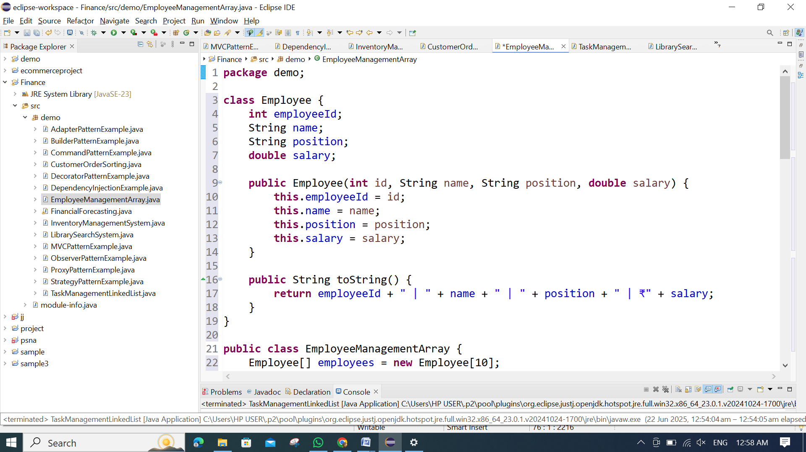

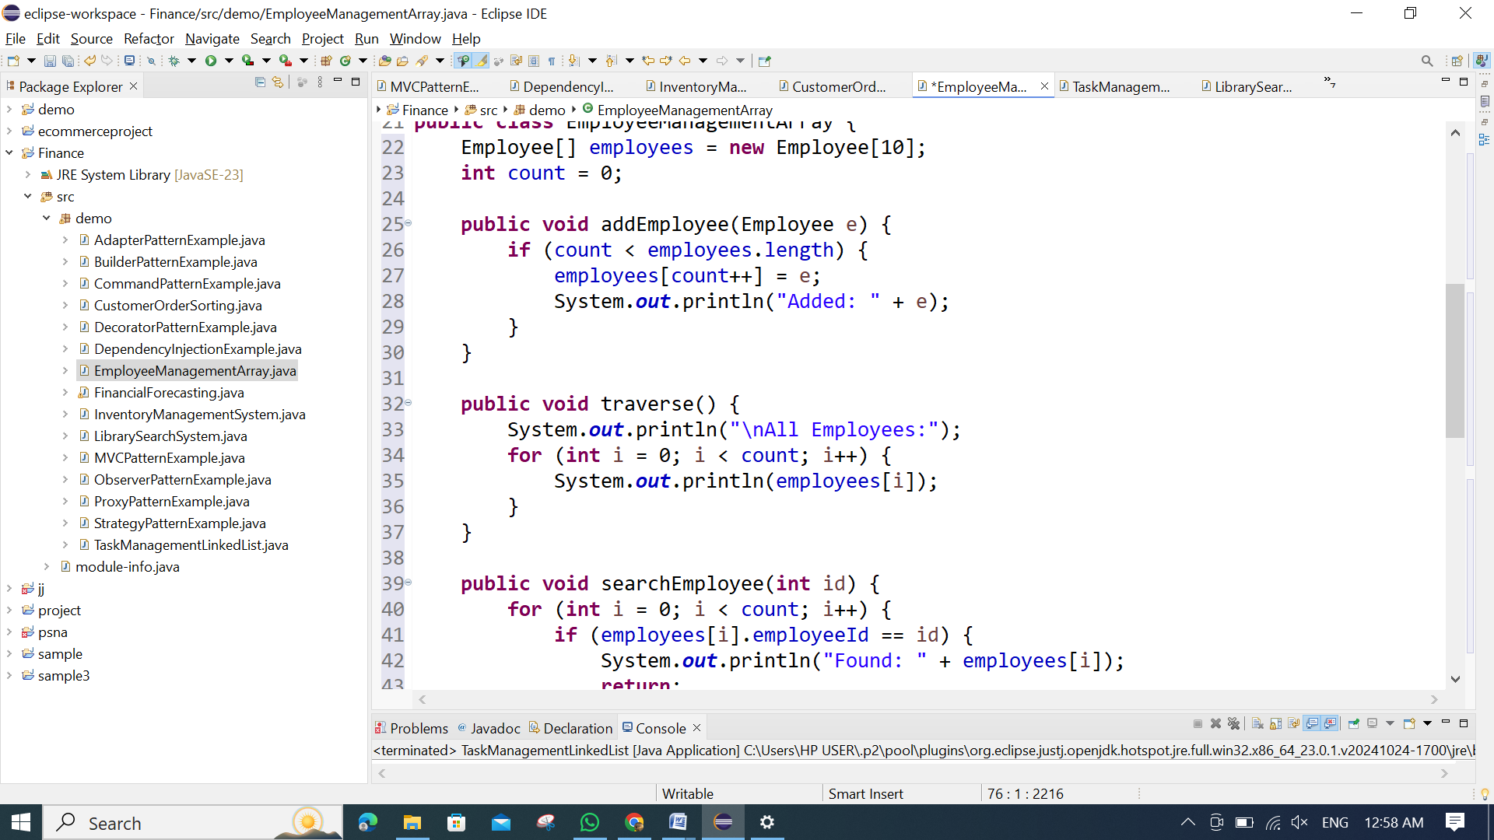 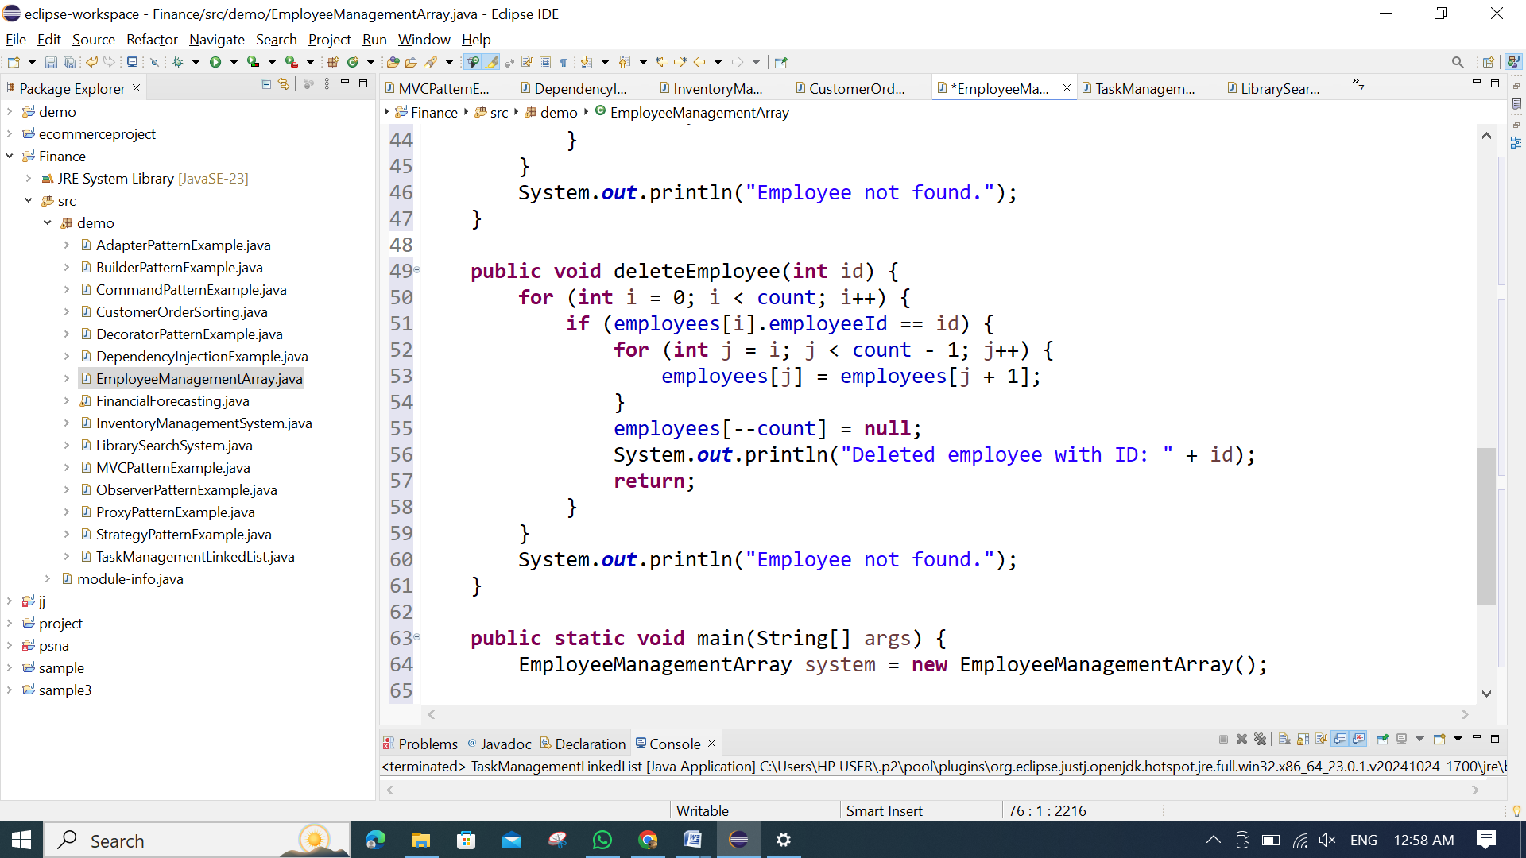 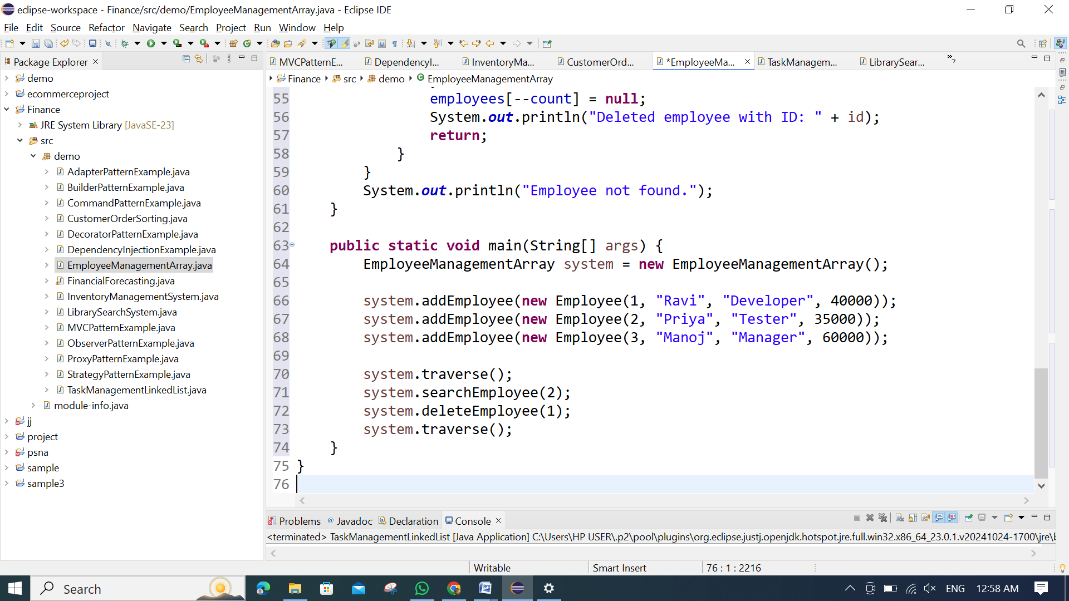

**OUTPUT:**

